CALL FOR DEMONSTRATIONS FOR PRESENTATION LAYER OF THE
TRAFFIC COORDINATION SYSTEM FOR SPACE (TraCSS)

1. Traffic Coordination System for Space (TraCSS) Overview

1.1. Background
TraCSS is the Department of Commerce's enterprise solution for ingesting, archiving, processing, and disseminating Space Situational Awareness (SSA) and Space Traffic Coordination (STC) data and products. TraCSS will provide conjunction analysis and warning services to civil and commercial satellite owner/operators. The system will store data from the Department of Defense (DoD), NOAA, commercial SSA data providers, commercial and civil satellite Owner/Operators (O/O). The TraCSS system will operate 24 hours per day, 7 days a week. An overview of the TraCSS is shown in Figure 1.
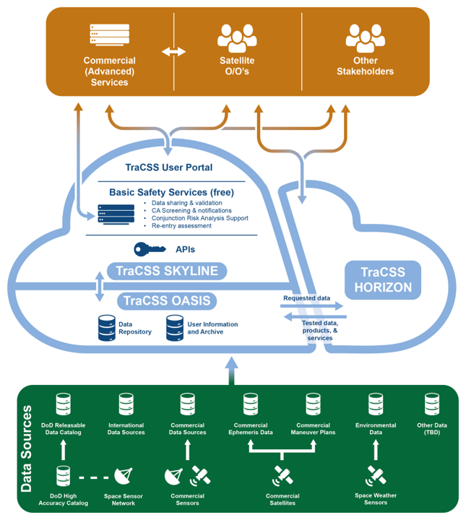
Figure 1: Overview of TraCSS (OV-1).
Figure 1 illustrates the TraCSS components, including: (a) sources of data; (b) TraCSS Interface (presentation layer); (c) TraCSS-SKYLINE (SSA application services); (d) TraCSS-OASIS (data repository); and (e) TraCSS-HORIZON, which is the computational environment where new applications and services may be developed and introduced into the TraCSS. The Government’s initial focus will be on providing the TraCSS services to support the basic safety cycle, which includes importing ephemerides and other data on space objects (satellites and space debris), performing quality checks on the data at ingest and every step of the processing cycle, and estimating if there are any close approaches. Per Space Policy Directive-3 (SPD-3), the basic safety cycle services will be offered free of direct user fees to serve the public interest.
TraCSS will be operated at an unclassified level and will not require storage or handling of any classified data. DoD data, with CUI handling requirements, will be ingested into the OASIS data repository. The DoD data will be further processed through an ITAR rated software system, and the resulting data products will not require any further special handling. The TraCSS system will be hosted on a GovCloud, which is procured through a separate procurement activity.
1.2 Presentation Layer Overview
The National Oceanic and Atmospheric Administration (NOAA), Office of Space Commerce (OSC), requires a presentation layer (user interface) for the Traffic Coordination System for Space (TraCSS). The TraCSS is being developed to fulfill the 2018 US National Space Council released SPD-3 to provide space traffic coordination services to the commercial and civil sector.
The Government seeks to leverage mature commercial capabilities for the TraCSS presentation layer which consists of web-based graphical user interfaces (GUI), machine-to-machine REST API, a message publication service to handle emails and text alerts, and a service to generate formatted human-readable data products (Figure 2). The Presentation layer will be the sole interface between the TraCSS system and all external data systems and users. The government recognizes that some development, both for GUIs and APIs, will be required to align with unique TraCSS requirements.
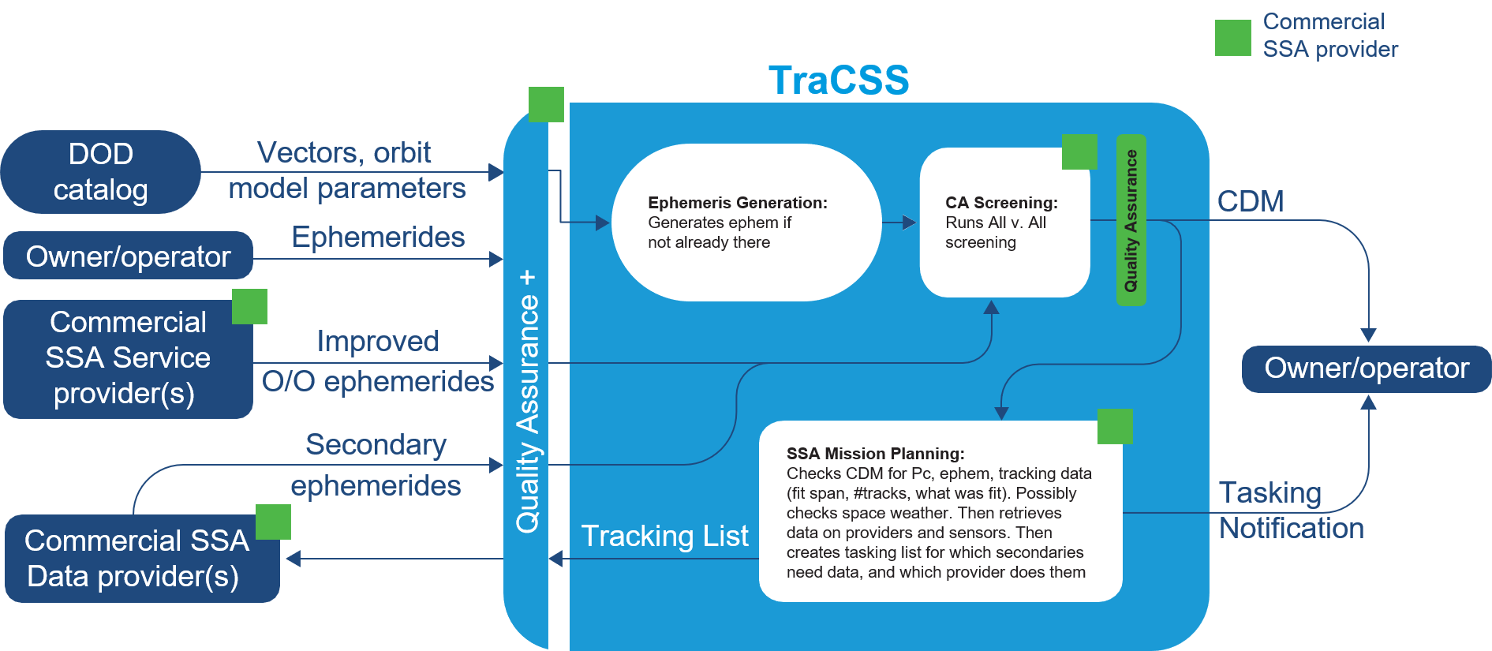

Figure 2: Conjunction Screening Data Interfaces.
For Phase 1, the Government plans to implement on-orbit conjunction screening at an unclassified level. Figure 2 illustrates the final Phase 1 instantiation which will be built up in increments starting in Q4FY24. The presentation layer capabilities are not expected to be available at Q4FY24, but will be fully functional by Phase 1.4 in Q4FY25.
As Figure 2 shows, conjunction screening includes ingesting state vectors, owner/operator ephemerides and other data on resident space objects (RSOs; satellites and space debris), performing automated quality checks on the data, automatically generating ephemerides from state vectors, and automated conjunction analysis (CA) screening for any close approaches. If objects are predicted to pass close by each other (and potentially collide), automated conjunction data message (CDM) warnings are generated and auto-distributed to involved parties to allow O/O’s time to determine a course of action to mitigate the potential collision. For objects in a CDM that are not well-tracked, a Mission Planning capability may be used to task commercial providers to make additional observations and supply updated ephemerides that would be re-screened at the next scheduled conjunction analysis, or sooner if warranted.
1.3 Presentation Layer Functionality
The presentation layer should provide a user-friendly interface that is easily navigable and accessible. Data and services available on the TraCSS Presentation Layer will be based on user role and responsibilities. This role-based access manages access to the STC and SSA content through user groups, permissions, and credentials. Users will be required to establish accounts to access services beyond basic publicly available data and services. TraCSS users include but are not limited to the following: the U.S. Government, academia, associations, launch vehicle owners, satellite owner/ operators (O/O), SSA data and service providers, and SSA research and development users. Users will be subject to sign-on based permissions for access consistent with the user agreement.

The TraCSS presentation layer shall provide graphical user interfaces that enable access to functionality that is specific to different types of user accounts. This includes, but is not limited to, the following:

- General Public User Account: Displays providing overview of predicted conjunctions with configurable thresholds and related public conjunction data, general system status, user registration, access to public data, public conjunctions of interest (surpassing a threshold)
- Registered Public User Account: In addition to the features provided to the General Public User the presentation layer should provide options for data download. It should also include a secure login feature to protect user data.
- Satellite Owner/Operator Account: The presentation layer should include features for receiving automated CDM warnings and submitting satellite data, including machine to machine capability. In addition, the presentation layer needs to provide detailed views of conjunctions of interest. it should also provide a secure login feature and forms for registration and data submission.
- Commercial SSA Data or Service Provider Account: The presentation layer should include features for data submission and receiving notifications as well as a secure login feature and forms for registration and any necessary forms.
- Inter-Government Agency Account: The presentation layer should include features for data import and export. In addition, the presentation layer should have data request and search functionality and detailed views for conjunctions of interest. It should also provide a secure login feature and forms for registration and agreement between agencies.
- International Partner Account: Similar to the Inter-Government Agency Account, but may need to include additional features or forms to accommodate international partners.
- HORIZON Account: The presentation layer should provide access to the HORIZON research environment. It should also provide a secure login feature and forms for registration.
- TraCSS Operator Account: The presentation layer should provide access to TraCSS operational data displays and interfaces for TraCSS system operators. In addition, the presentation layer provides access to detailed displays that allow monitoring of conjunction screening alerts, off-nominal events or close approaches, operator ephemerides monitoring, CDM production monitoring and search. It should also provide a secure login feature.
- TraCSS OSC Government User: The presentation layer should provide access to all data, but without administrative or edit privileges. It should also provide a secure login feature.

TraCSS will use the Consultative Committee for Space Data System (CCSDS) standards for data input/output. Consequently, the presentation layer will also need to enable exchanges that retain the state of the information. The REST API shall manage all machine-to-machine interfaces between TraCSS and external non-person entity users including, but not limited to, the following:

- Satellite Owner/Operator: Submitting satellite data to TraCSS for the Improved Owner/Operator Ephemeris Commercial Data Provider to process and generate improved ephemerides. Submit general satellite data, submit satellite ephemerides, including maneuver plans.
- Commercial Data Provider: Receiving tasking from TraCSS for additional observations on conjuncting objects in the appropriate CCSDS file format and submitting CCSDS-format ephemeris files to TraCSS.
- Inter-Government Agency: Access for other US government agencies. During Phase 1 the initial agency will be DoD. DoD will provide state vectors and orbit model parameters to TraCSS and receive state ephemerides and state vector data from TraCSS. The interface between DoD/TraCSS may be push or pull on both sending and receiving data. Interface shall be defined in consultation with OSC and DOD and approved by the Government.
- International Partner: Similar to inter-government agency interface.
- HORIZON: Research environment displays and APIs

2.0. Scheduling a Demonstration of Existing Capabilities

The government seeks to understand and observe demonstrations of existing commercial capabilities that align with the GUI and REST API requirements for displaying and accessing space situational data (SSA) and services foreseen for Traffic Coordination System for Space (TraCSS). For interested vendors attending the 2024 National Space Symposium in Colorado Springs, the government will be available to schedule 30-minute sessions for demonstrations on existing capabilities on Tuesday, April 9, 2024 and Wednesday, April 10, 2024 between 12:30-5:00 pm (MT). It is assumed that demonstrations at the Space Symposium will take place in the vendor’s booth. For interested vendors not attending the 2024 Space Symposium in Colorado Springs, virtual 30-minute sessions will be available the week of April 15, 2024. To schedule a demonstration session, please use the following link:
https://www.space.commerce.gov/about/meeting-request-form/
Select for the following fields:
- Are you requesting to meet with specific OSC personnel? Select: Sandy Magnus
- Discussion Topic: Select: Other
- Specific discussion topic/request: Input: TraCSS Presentation Layer Demo
- Proposed dates/times: Input: Your desired date/time
  - Note: Sessions will be 30 minutes. We will do our best to accommodate your preference but may have to coordinate alternative date/time.
- Virtual or in person:
  - Select: In-person at conference, company site, etc. (for demonstration week of April 8 at Space Symposium)
  - Select: Virtual (for demonstration week of April 15)
Deadline for signing up is: March 21, 2024
In-person and virtual sessions will be considered equally; no differentiation will be made.
The purpose of the demonstrations is for the government to understand and explore what user interface capabilities directly relevant to the provision of space situational awareness data and services are currently available.
Will be scheduling based on government availability and relevance to TraCSS requirements as described in this white paper.
3.0. Presentation Demonstration Questions
In addition to a demonstration of existing capabilities, the government is seeking information on the following questions:
- Of the notional user group and displays outlined above, which users do you already have native displays for and what is the functionality of the displays available?

- Of the notional REST APIs outlined above, which do you already have native capability available?

- Have you ever integrated your product into another vendor’s system before? If so, what were your lessons learned? Please explain your product’s requirements and dependencies and how they must be addressed in order to integrate your product into another vendor’s system.

- What is your experience base with agile development methods and how did you use it to develop your software? Describe your method for producing a display.

- What is your continuing improvement/development plan for your software?

- What is your experience publishing, documenting, adjusting, and maintaining REST API user interfaces?

- What data standards, types, and formats do you have experiencing ingesting and egressing?

- Is your software based on containerized microservices with Kubernetes? If not, describe your approach to adapting your software to operate in a Kubernetes environment.

- Describe your software architecture. Show you separate concerns between displays, control logic and data access, including one or more diagrams.

Written responses to the above questions shall be submitted no later than April 24, 2024 at 1:00 pm ET to the Contract Specialist, with a copy to the secondary point of contact to the email addresses listed below.

Primary Point of Contact:
Amber Behrns
Contract Specialist
amber.behrns@noaa.gov

Secondary Point of Contact:
Noelle Albert
Contracting Officer
noelle.albert@noaa.gov

